**LAPORAN PRAKTIKUM PEMROGRAMAN BEORIENTASI OBJEK**

“Tugas 09 – Nested Class*”*



Oleh:

Nama : Avryzel Alifian Hakim

NPM : 4523210121

Kelas : A

Dosen:

Adi Wahyu Pribadi , S.Si., M.Kom

**S1-Teknik Informatika**

**Fakultas Teknik Universitas Pancasila**

**2023/2024**

1. **Sistem Manajemen Buku**

* Library.java

package *app*;

*public* *class* Library {

*static* String libraryName;

*public* *static* String getLibraryName() {

        return libraryName;

    }

*static* *class* Book {

*private* String title;

*private* String author;

*private* String isbn;

*public* Book(String title, String author, String isbn) {

            this.title = title;

            this.author = author;

            this.isbn = isbn;

        }

*public* void displayBookInfo() {

            System.out.println("NamaPerpustakaan:" +

                    Library.getLibraryName());

            System.out.println("JudulBuku:" + title);

            System.out.println("Penulis:" + author);

            System.out.println("ISBN: " + isbn);

            System.out.println("_____________________________");

        }

    }

}

* Main.java

package *app*;

*public* *class* Main {

*public* *static* void main(String[] args) {

*// Mengatur namaper pustakaan*

        Library.libraryName = "Perpustakaan Kota";

*// Membuat objek buku*

        Library.Book book1 = new Library.Book("Pemrograman Java", "Budi", "1234567890");

        Library.Book book2 = new Library.Book("Algoritma dan Struktur Data", "Siti", "0987654321");

*// Menampilkan informasi buku*

        book1.displayBookInfo();

        book2.displayBookInfo();

    }

}

* Hasil Running

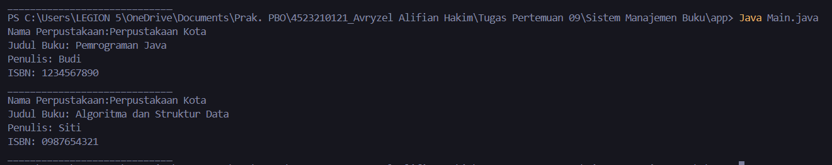

1. **Sistem ATM**

* ATM.java

package *com*;

*public* *class* ATM {

*private* String location;

*public* ATM(String location) {

        this.location = location;

    }

*class* BankAccount {

*private* String accountNumber;

*private* double balance;

*public* BankAccount(String accountNumber) {

            this.accountNumber = accountNumber;

            this.balance = 0.0;

        }

*public* void deposit(double amount) {

            if (amount > 0) {

                balance += amount;

                System.out.println("Deposit: Rp" + String.format("%,.2f", amount));

            } else {

                System.out.println("Jumlah deposit harus positif.");

            }

        }

*public* void withdraw(double amount) {

            if(amount > 0 && amount <= balance) {

                balance -= amount;

                System.out.println("Withdraw: Rp" + String.format("%,.2f", amount));

            } else {

                System.out.println("Penarikan tidak valid.");

            }

        }

*public* void displayAccountInfo() {

            System.out.println("Lokasi ATM " + ATM.this.location);

            System.out.println("Nomor Akun: " + accountNumber);

            System.out.println("Saldo Sekarang: Rp" + String.format("%,.2f",balance));

            System.out.println("__________________________");

        }

    }

}

* Main.java

package *com*;

*public* *class* Main {

*public* *static* void main(String[] args) {

*// Membuat objek ATM*

        ATM atm = new ATM("Jakarta");

*// Membuat objek BankAccount melalui objek ATM*

        ATM.BankAccount account = atm.new BankAccount("0011223344");

*// Menampilkan saldo awal*

        account.displayAccountInfo();

*// Melakukan deposit*

        account.deposit(1000000);

        account.displayAccountInfo();

*// Melakukan withdraw*

        account.withdraw(500000);

        account.displayAccountInfo();

    }

}

* Hasil Running

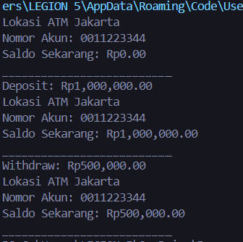

1. **Factorial Calculator**

* Calculator.java

import *java.util.Scanner*;

*public* *class* Calculator {

*public* void calculate(int number) {

*// Local Inner Class*

*class* Factorial {

*private* int n;

*public* Factorial(int n) {

                this.n = n;

            }

*public* int getResult() {

                int result = 1;

                for(int i = 2; i <= n; i++) {

                    result *= i;

                }

                return result;

            }

        }

*// Membuat objek dari Local Inner Class*

        Factorial factorial = new Factorial(number);

        int result = factorial.getResult();

        System.out.println("Faktorial dari " + number + " adalah " + result);

    }

*public* *static* void main(String[] args) {

        Scanner scanner = new Scanner(System.in);

        System.out.println("Masukkan angka: ");

        int num = scanner.nextInt();

        Calculator calculator = new Calculator();

        calculator.calculate(num);

        scanner.close();

    }

}

* Hasil Running

Penjelasan:

120 adalah hasil dari factorial 5 dengan cara 5 x 4 x 3 x 2 x 1.

1. **Anonymous Inner Class - Timer Sederhana**

* SimpleTimer.java

import *java.util.Timer*;

import *java.util.TimerTask*;

*public* *class* SimpleTimer {

*public* *static* void main(String[] args) {

        System.out.println("Timer dimulai ");

        Timer timer = new Timer();

        TimerTask task = new TimerTask() {

            int counter = 1;

            @Override

*public* void run() {

                if (counter <= 5) {

                    System.out.println("Detik ke " + counter);

                    counter++;

                } else {

                    System.out.println("Timer selesai.");

                    timer.cancel();

                }

            }

        };

*// Menjadwalkan tugas setiap 1 detik(1000 ms)*

        timer.scheduleAtFixedRate(task, 0, 1000);

    }

}

* Hasil Running

